To start using Typescript:

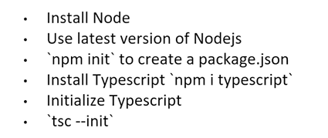

Angular setup:

If you want to use a local angular version for a project instead of the global one:

npx -p @angular/cli@13 ng new sample-application

in this case we use Angular 13 to create an app called sample-application

Install an older Angular version locally:

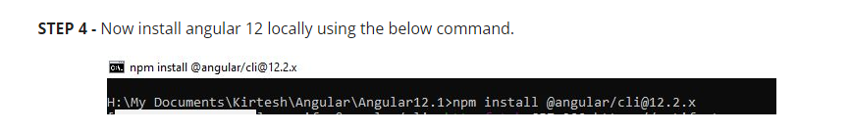

Mono-repo:

In angular you can have multiple app and libraries in the same repo

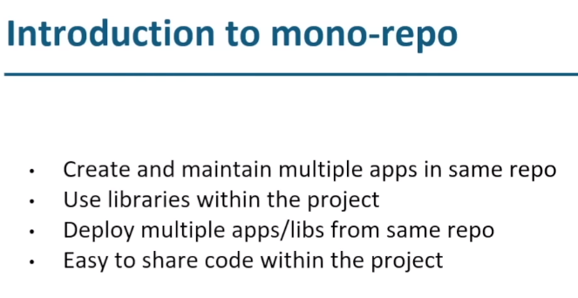

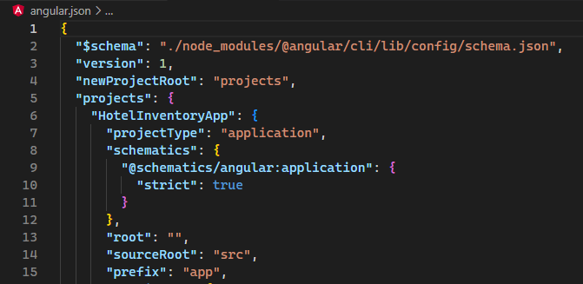

When we create a new component it will have the prefix defined here, app in this case

It is possible to change this when we create a new app with the switch:

|  |  |
| --- | --- |
| --prefix | The prefix to apply to generated selectors for the initial project. |

A list of all the switches are here: <https://angular.io/cli/new>

Directives:

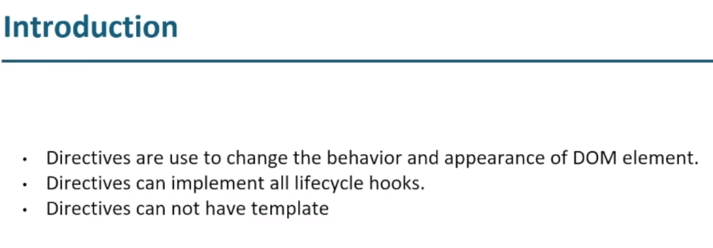

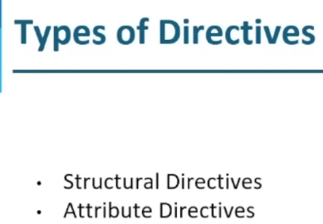

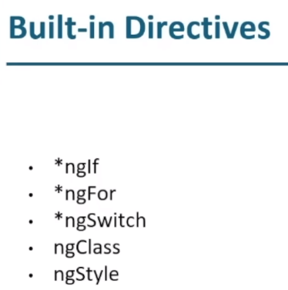

Structural directives modify the DOM and start with an *

Attribute directives can modify the DOM, add or modify an attribute but can’t add or remove an element

*ngIf:

<!-- We render the room list if they are available rooms -->

<div *ngIf="rooms.availableRooms > 0">Rooms list:</div>

*ngFor

<tr *ngFor="let room of roomList; let e = even; let o = odd; let i = index">

      <td>{{ i + 1 }}</td>

      <td>{{ e ? "Even" : "Odd" }}</td>

      <td>{{ room.roomNumber }}</td>

even, odd and index are part of *ngFor.

*ngSwitch

role = 'user';

<div [ngSwitch]="role">

  <div *ngSwitchCase="'user'">Welcome User!</div>

  <div *ngSwitchCase="'admin'">Welcome Admin!</div>

  <div *ngSwitchDefault>You are not authorized!</div>

</div>

We use “ ’user ’ ” because the test of the cases is on a string not a variable!

ngClass:

 <!-- With ngClass we change the background color of each line based if the line is even or odd -->

    <!-- we change the name of the class between even or odd -->

    <tr

      [ngClass]="e ? 'even' : 'odd'"

ngStyle:

<!-- the color of the inner text depends if they are available rooms -->

  <!-- if available then in green if not in red -->

  <span

    [ngStyle]="{ color: rooms.availableRooms ? 'green' : 'red' }"

    [innerText]="numberOfRooms"

  ></span>

Pipes: